1. Install Eclipse IDE for Java Developers <https://eclipse.org/downloads/eclipse-packages/?show_instructions=TRUE>

Follow instructions on page.

1. Install Java SE <https://www.java.com/ru/download/help/windows_manual_download.xml>

Follow instructions on page.

1. Install JDK:

<http://www.oracle.com/technetwork/pt/java/javase/downloads/jdk8-downloads-2133151.html>

Choose Java SE Development Kit, according to you PC OS (e.g Windows x64)

1. Create the Environment Variable JAVA_HOME

[**https://www.java.com/ru/download/help/path.xml**](https://www.java.com/ru/download/help/path.xml)

**For Win 10:**

* Go to Control panel –> System and Security –> System –>Advanced system settings –> Advanced –> Environment Variables
* Add new System variable
* enter JAVA_HOME as “the Variable name” and jdk path
* alter the 'Path' variable so that it also contains the path to the Java executable. Example, if the path is currently set to 'C:\WINDOWS\SYSTEM32', then change your path to read 'C:\WINDOWS\SYSTEM32;c:\Program Files\java\jdk\bin'.

1. Load Test project to Eclipse

File🡺 Import🡺 General 🡺 Projects from Folder or Archive

In “Import source” field, choose directory with Project.

Push Finish.

In “Package Explorer” Tab Project is displayed.

1. If “3rdParty” folder in Project is empty - Download external Jars from:

<http://www.seleniumhq.org/download/>

1. Download Selenium Standalone server
2. Selenium Html Runner

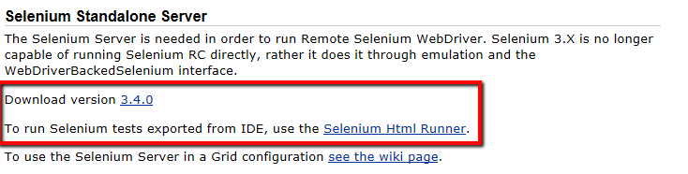

1. Download: The Internet Explorer Driver Server
2. Download: Selenium Client & WebDriver Language Bindings 🡺 Java
3. Third Party Browser Drivers :(Mozilla Geckodriver, Google Chrome driver, Opera, Microsoft Edge Driver, safariDriver )
4. Install: JUNIT - <https://github.com/junit-team/junit4/wiki/Download-and-Install> ) - use latest junit.jar
5. https://logging.apache.org/log4j/1.2/download.html 🡺 bin

We will need only 2 files:

* Download Log4j-api-2.8.2.jar

* Download Log4j-core-2.8.2.jar

1. Add Drivers with .EXE extensions to Project folder (e.g. C/Users/User/workspace)
2. Add external jar files to java build path in IDE

* Now you need to add selenium webdriver's jar files in to java build path.
* **Right click on** project 'testproject' > **Select** Properties > **Select** Java build path > **Navigate to** Libraries tab
* **Click on** add external JARs button > **select** both all needed .jar files

1. Install browsers, if needed
2. Run tests by:

* Src 🡺 webshopAutoTests 🡺 doubleclick on any test 🡺 rightclick on test code 🡺 Run as 🡺 Junit Test

My test Environment:

Version 59.0.3071.115 (Official Build) (64-bit)

Windows 10 Pro

Eclipse Java EE IDE for Web Developers.

Version: Neon.3 Release (4.6.3)

JavaSE 1.8

P.S. get sources for Jars (maven)